Effect of combined Escherichia coli vaccination and antibiotic restriction on antimicrobial use, mortality and growth in women-owned smallholder broiler flocks: a cluster-randomised crossover trial in northern Tanzania
Pauline Gitonga^{1,2,3}*, Douglas Mesa¹, Emily Kiugu^{1,4}, Brian Ogoti^{1,2}, Sharadhuli Iddi Kimera⁵, Stella Kiambi⁶, Tetiana Miroshnychenko⁷, Erik Mitjen⁷, Susan Rodakis⁷, Raymond Tiernan⁸, Mweene Cheelo⁷, Peter Kimeli⁹, Gabriel Shirima¹⁰
Affiliations
¹ ASAL eXtension, P.O. Box 59263–00200, Nairobi, Kenya
² Centre for Epidemiological Modelling and Analysis (CEMA), University of Nairobi, P.O. Box 30197–00100,
Nairobi, Kenya
³ Department of Biomedical Sciences, Colorado State University, Fort Collins, CO 80523, United States
⁴ Department of Veterinary and Biomedical Sciences, University of Minnesota, Saint Paul, MN 55108, United States
⁵ Department of Veterinary Medicine and Public Health, College of Veterinary Medicine and Biomedical Sciences, ,
Sokoine University of Agriculture (SUA), P.O. Box 3021, Morogoro, Tanzania
⁶ Food and Agriculture Organisation of the United Nations (FAO), P.O. Box 9754, Dar es Salaam, Tanzania
⁷ Zoetis Inc., Parsippany, New Jersey, United States
⁸ Centre of Excellence, Zoetis, Dublin, Ireland
⁹ Depatment of Clinical Studies, Faculty of Veterinary Medicine, University of Nairobi, P.O. Box 30197–00100,
Nairobi, Kenya
¹⁰ Nelson Mandela African Institution of Science and Technology (NM-AIST), P.O. Box 447, Tengeru, Arusha,
Tanzania
*Corresponding author
Dr Pauline Gitonga
pauline.gitonga@cema.africa
ORCID iD: https://orcid.org/0000-0002-1160-5625

Abstract
Background: Preventive antibiotic use is widespread on smallholder poultry farms in sub-Saharan Africa and contributes to antimicrobial resistance, yet few stewardship interventions have been evaluated there. We assessed whether combining Escherichia coli vaccination with antibiotic withholding could reduce antibiotic use without harming mortality or growth on women-owned smallholder broiler farms in northern Tanzania.
Methods: In this cluster-randomised crossover trial, 44 farms each completed one vaccinated and one control cycle in random order, each its own control (88 farm-cycles; 28,156 birds). Vaccinated flocks received Poulvac® E. coli, a live attenuated aroA-deleted O78 vaccine, in drinking water on day 5, with antibiotics withheld on days 0–14. Outcomes were antibiotic-use frequency to day 35, mortality to day 21 and weight gain over days 3–21.
Results: Vaccinated cycles recorded fewer antibiotic-use events than control cycles (23 versus 88; incidence-rate ratio 0.25, 95% CI 0.18–0.33; p<0.001) and fewer WHO highest-priority critically important antimicrobial events (14 versus 41; IRR 0.31; p<0.001). Use was concentrated on days 0–14 (1 of 44 vaccinated versus 33 of 44 control cycles; p<0.001) and did not differ on days 15–35, when both arms could treat freely (p=0.47). Mortality to day 21 was 1.7% versus 2.4% (farm-weighted rate ratio 0.95, 95% CI 0.73–1.23; p=0.70). Weight gain over days 3–21 did not differ (−1.67 g/bird/day, 95% CI −3.98 to +0.65; p=0.16), though vaccinated birds grew more slowly over days 3–14 (−2.80 g/bird/day; p=0.001), resolving by day 21. Adherence was 97.7%.
Conclusions: The combined strategy reduced early-cycle antibiotic exposure, including antibiotics critically important for human medicine, without a detected increase in mortality or sustained reduction in growth. However, these estimates were imprecise and underpowered to exclude small effects. Because the control arm received neither vaccination nor withholding, the vaccine's independent contribution could not be determined; future trials should include an antibiotic-withholding-only arm.

Keywords: antimicrobial stewardship; antimicrobial resistance; Colibacillosis; Escherichia coli vaccine; broiler; smallholder; cluster-randomised crossover trial; Tanzania

Introduction
Antibiotic resistance is a major global health threat. In 2019, bacterial antimicrobial resistance (AMR) was estimated to have caused 1.27 million deaths worldwide, with a disproportionate burden in low- and middle-income countries (LMICs) (1). Food-animal production is a major and growing consumer of antimicrobials. Global consumption was estimated at 63,151 tonnes in 2010 and projected to reach 105,596 tonnes by 2030, an increase of approximately 67 percent (%), driven largely by the intensification of livestock production in low- and middle-income countries (2). A substantial proportion of antibiotic use in food animals is for non-therapeutic purposes, including disease prevention and growth promotion, and involves antibiotic classes that the World Health Organisation (WHO) classifies as critically important for human medicine(3,4). Poultry is one of the fastest-growing livestock sectors in sub-Saharan Africa. Smallholder broiler production provides an important source of income and nutrition and is frequently managed by women (5). In these systems, limited access to veterinary services and persistent outbreaks of infectious disease may encourage farmers to obtain antimicrobials without a prescription and use them preventively(6). Such practices increase selection pressure for resistant bacteria that may circulate among animals, people and the environment. Reducing unnecessary antimicrobial use is therefore a One Health priority. However, restrictions that limit access to treatment without providing effective alternatives may adversely affect smallholder farmers who depend on their flocks for income and food security. Interventions that prevent disease and reduce the need for treatment may offer a more sustainable approach (7).
Colibacillosis, caused by Avian Pathogenic Escherichia coli (APEC), remains one of the most common and costly bacterial diseases of broilers, responsible for the vast majority of production and economic losses globally (8). Exacerbating this challenge is growing evidence of E. coli resistance to critical antibiotics on commercial poultry farms, making conventional therapeutic treatments increasingly ineffective (9,10). Reducing the need for antibiotic treatment, rather than relying solely on regulatory caps to restrict antibiotic use, is therefore a central objective of global antibiotic stewardship (11). A live attenuated aroA-deleted E. coli O78 vaccine, Poulvac® E. coli, has been evaluated under experimental and commercial production conditions. Previous studies have reported reductions in Colibacillosis-associated lesions and mortality and, in some settings, improvements in growth or reduction in antibiotic use (12–14). However, most of the available evidence comes from large-scale commercial poultry operations with relatively high levels of biosecurity and production inputs, primarily in middle- and high-income countries (15). Evidence on the vaccine's effectiveness under low-resource smallholder conditions in sub-Saharan Africa remains limited. To address this gap, we conducted a cluster-randomised crossover study on women-owned smallholder broiler farms in northern Tanzania. Our primary objective was to evaluate whether a combined Poulvac® E. coli vaccination and antibiotic-withholding strategy reduced on-farm antibiotic use without adversely affecting mortality or Average Daily Weight Gain (ADWG), supporting its role as an antimicrobial stewardship intervention in low-resource poultry systems. We hypothesised that the intervention would reduce antibiotic use without adversely affecting mortality or growth.
Materials and Methods
Ethical considerations
Ethical approval was granted by the Kibong'oto Infectious Diseases Hospital–Nelson Mandela African Institution of Science and Technology–Centre for Educational Development in Health, Arusha (KIDH–NM-AIST–CEDHA) Research Ethics Committee (Approval No: KNCHREC00039/01/2024). Additional research authorisation was provided by the Tanzania Livestock Research Institute (TALIRI; Ref: BA/308/355/01A/110). Local administrative permissions were obtained from the Kilimanjaro and Meru District Councils. Participation was strictly voluntary, and written informed consent was obtained from all participants prior to data collection. No individually identifying information was collected.
Study design
To evaluate the real-world effectiveness of the Poulvac® E. coli vaccine intervention, a cluster-randomised crossover trial was conducted on women-owned smallholder broiler farms in the Arusha and Kilimanjaro regions of northern Tanzania. The farm was the cluster and unit of randomisation, while each farm-cycle represented one period-level observation. Each participating farm completed two consecutive production cycles: one intervention cycle and one control cycle, in a randomly assigned order. This design enabled each farm to serve as its own control. The two cycles were separated by an all-out/all-in destocking, cleaning and restocking period to minimise carry-over between flocks. The study was designed in accordance with guidance for cluster-randomised crossover trials (16). The trial was designed and initiated as a farmer-facing effectiveness evaluation of a licensed commercial product under routine smallholder management, rather than as a clinical trial to test the efficacy of an investigational agent, and the requirement for prospective registration was not indicated.
Sample size
The study was designed with 80% power to detect a five-percentage-point difference between the intervention and control groups at a two-sided 5% significance level. The calculation assumed an average of 250 birds per farm, a coefficient of variation of 0.7, a within-period intra-cluster correlation coefficient of 0.03, and no correlation between periods because farms used an all-in/all-out production system (17). Based on these assumptions, 52 farms were required: 26 in Arusha and 26 in Kilimanjaro. Each farm was required to keep at least 100 birds. For the growth analysis, 50 birds were selected for repeated weighing in each farm-cycle. However, the farm-cycle, not the individual bird, was the unit of analysis. The selected birds were therefore used to estimate the mean growth for each cycle, rather than as independent observations. Power for the growth outcome depended on the number of farms and the correlation between each farm's two cycles, not on the number of birds weighed. The achieved precision is shown by the confidence intervals and p values.
Study area and target population
The trial was conducted in two regions of northern Tanzania: Arusha region (Meru district, Usa River and Imbaseni wards) and Kilimanjaro region (Moshi municipality, Kilimanjaro and Soweto wards). A baseline biosecurity and management survey of 110 women-owned smallholder broiler farms was conducted to establish the sampling frame. Farms were eligible when they were owned and solely operated by women; maintained flocks of 100–500 broilers; had at least two years of broiler-production experience; reared broilers to approximately 35 days of age; followed an all-in/all-out production system; routinely vaccinated their flocks; used enclosed broiler housing; and provided written informed consent. The women operating the farms were the sole decision-makers for flock management. Of the 110 farms assessed, 52 farms enrolled and were randomised. Forty-four farms, 24 in Arusha and 20 in Kilimanjaro, contributed to the final analysed dataset. Of the eight farms not analysed, five were lost to follow-up after the first production cycle and did not begin the second, and three completed both cycles but were excluded for pre-specified scientific and safety reasons: one farm was flooded during the study with the loss of 97 birds, one was non-compliant due to lack of disclosure to the research assistants of using antibiotics during the treatment phase a fact that was discovered when the birds were being harvested, and one experienced a biosecurity breach in which outside chickens were introduced into the same housing as the study flock (Figure 1).
Randomisation and blinding
The 52 enrolled farms were allocated in a 1:1 ratio to one of two treatment sequences: vaccination followed by control, or control followed by vaccination. The allocation sequence was generated in Microsoft Excel using its pseudo-random number function, stratified by region. Enrolment was opportunistic rather than scheduled: farms entered the trial as and when the farmer purchased a batch of day-old chicks, so recruitment followed farmers' own restocking cycles and placements were staggered between 17 November 2025 and 16 April 2026. Because the vaccine was administered through drinking water by the field team, neither farmers nor field personnel were blinded to treatment allocation. However, the primary outcomes recorded deaths, bird weights and antibiotic-use events were objectively measured using standardised data-collection techniques.
One protocol-mandated exception to the allocated sequence applied. The manufacturer's product information states that only birds in good health should be vaccinated, and that birds showing clinical respiratory signs must not be vaccinated. Where a flock presented with sick birds at the point when vaccination would have been due, it could not be vaccinated, and that production cycle was run as a control cycle, overriding the allocated sequence. This is a departure from strict randomised allocation, but it was invoked infrequently and produced no detectable imbalance in baseline health: clinical signs recorded before vaccination (days 0 and 3) occurred in 5 of 44 control cycles and 6 of 44 vaccinated cycles (Fisher's exact p = 1.00), with pre-vaccination sickness confined to the control cycle in 4 farms and to the vaccinated cycle in 5 (McNemar's exact p = 1.00). Baseline flock size was comparable between arms (mean birds placed 314 vaccinated versus 326 control; p = 0.73).
Intervention
Vaccinated flocks received Poulvac® E. coli (Zoetis Inc., Parsippany, New Jersey, USA), a live attenuated aroA-deleted E. coli serotype O78 vaccine. The vaccine was purchased by the study team from the local commercial supply chain at prevailing market price; it was not donated or supplied by the manufacturer, and the trial therefore reflects the product as a smallholder farmer would actually obtain it. Knowledge of the true purchase price also anchors the willingness-to-pay responses reported below. The locally available commercial presentation contained 2,500 doses and was designed principally for flocks larger than the 100–500-bird flocks enrolled in this study. Zoetis ALPHA therefore provided a written technical protocol, dated 22 September 2025, to adapt the product for small flocks while maintaining the recommended dose per bird. The adaptation adjusted the administered volume based on the number of live birds but did not change the intended per-bird vaccine dose. The lyophilised contents of the 2,500-dose vial were reconstituted in 5 mL of stabilised, dechlorinated water. The reconstituted vaccine suspension was administered at a target volume of 1 mL per 500 live birds, with the required aliquot calculated according to the number of birds present on the day of vaccination.
The calculated vaccine aliquot was first mixed with approximately 10% of the required vaccination water and then added to the remaining volume. Drinking water was withheld for four hours before vaccination to encourage prompt and uniform consumption of the vaccine-treated water. The required volume of vaccination water was determined by triangulating published age-specific estimates of broiler water intake (19) with the volume routinely provided to the flock. The vaccine-treated water was administered in the early morning and made available for two hours. Any remaining vaccine solution was then removed and safely discarded, after which fresh drinking water was provided. An anti-chlorine water stabiliser containing blue dye (ImmuNeo Granule, Aether Centre (Beijing) Biology Industry Co. Ltd, Beijing, China) was added to the vaccination water at the label rate of 10 g per 100 L before reconstitution, to neutralise residual chlorine that would otherwise reduce the viability of the live vaccine organism and to provide visual confirmation that the vaccine-treated water had been consumed. Vaccination was administered only to flocks considered clinically healthy on the day of administration.
Vaccination was administered through drinking water on day 5 after chick placement. Routine antibiotic administration and the use of acidifiers and water disinfectants were withheld throughout the protocol-defined peri-vaccination restriction period, which spanned days 0–14 of the production cycle. Following this restriction period, farmers resumed their usual treatment practices. Control flocks did not receive Poulvac® E. coli and were not subject to the antibiotic-withholding protocol.
The study also provided footbaths, whose use was verified photographically and whose provision was balanced across arms (41 of 44 vaccinated versus 39 of 44 control cycles). Multivitamin sachets were provided to 43 of 44 vaccinated cycles and, where requested because the farmer did not have their own, to 6 of 44 control cycles. Multivitamin use was not restricted by protocol in either arm, and farmers in both arms commonly used their own product. Multivitamins are a routine component of smallholder broiler management in this setting and are frequently formulated together with antibiotics, so multivitamin administration is not independent of antibiotic administration. All other husbandry practices continued according to each farmer's routine procedures in both study arms. These included feeding, housing, biosecurity and routine vaccination against Newcastle disease (ND) and Infectious Bursal Disease (IBD/Gumboro).
Data collection and outcomes
Data were collected using structured electronic questionnaires developed on the Open Data Kit platform and administered on handheld tablets. The study instruments included a production-monitoring questionnaire and an end-of-study questionnaire. Scheduled farm visits were conducted on days 0, 3, 5, 14, 21, 28 and 35 of each production cycle, so intervals between consecutive visits ranged from two to nine days. Eleven trained research assistants collected the data, each assigned to between two and five farms. To reduce the risk of pathogen transmission between study farms, each research assistant visited only one farm per day. At each visit, data were collected on the number of birds remaining in the flock, deaths since the preceding visit, clinical signs, antibiotic use and feed consumption. Antibiotic use was elicited at each visit by asking whether any antibiotics had been administered during the preceding visit, and records included, where available, the product name, active ingredient and reported purpose of administration. On day 3, 50 birds were randomly selected from each flock, marked on the head with a permanent marker pen for identification and weighed individually. Weighing was not performed at the day-0 or day-5 visits. The same marked birds were reweighed at the day 14, 21, 28 and 35 visits where they remained present in the flock. Where suitable carcasses were available, birds that had died were submitted to the Tanzania Veterinary Laboratory Agency (TVLA) for post-mortem examination and bacteriological analysis. After completion of both production cycles, farmers completed an exit questionnaire addressing their perceptions of vaccine performance, antibiotic use, flock mortality and growth, willingness to purchase or recommend the vaccine, and major production challenges.
The three primary outcomes were: (i) cumulative mortality relative to birds placed, with day 21 as the primary endpoint and day 28 as a sensitivity analysis; (ii) Average Daily Weight Gain (ADWG, g/bird/day), with days 3–21 as the primary window and days 3–28 as a sensitivity analysis; and (iii) antibiotic-use frequency, defined as the number of monitoring visits per cycle at which any antibiotic use was reported, assessed through day 35. Day 21 was chosen as the primary end point for mortality and growth because harvesting began from day 21 onward. After that point, recorded losses could no longer be separated cleanly from harvest off-take. Antibiotic use was assessed through day 35 because cycles that remained on farm that long did so mainly because sick birds were still present. Restricting the window to day 21 or 28 would therefore have under-counted the therapeutic use that these prolonged, higher-risk cycles generated.

Secondary outcomes were the use of WHO highest-priority critically important antimicrobials (HPCIAs), recorded clinical signs, adherence to the vaccination protocol, and farmers' perceptions of the intervention from the exit questionnaire.
An antibiotic-use event was defined as a seven-day monitoring interval in which one or more antibacterial products were recorded. Products were classified by pharmacological class. Chemical anticoccidials with no antibacterial activity Amprolium and Toltrazuril and non-antibacterial supportive products such as Ambroxonil were excluded from the antibiotic-use outcome. Records naming only excluded products were reclassified out; this affected five records (three Amprolium, one Toltrazuril, one Ambroxonil), all of which occurred in control cycles. Records naming an excluded product alongside an antibacterial one remained within the outcome. Antibiotic use recorded at the day-0 placement visit was retained. Because farms operated all-in/all-out with cleaning, disinfection and at least two weeks of downtime between cycles, no birds were present on the farm during the seven days preceding placement; an antibiotic recorded at that visit therefore refers to administration to the incoming flock at placement. Five such records occurred, all in control cycles, and all named antibiotics (Oxytetracycline, Neomycin or Enrofloxacin). They represent first-day prophylaxis, the practice this intervention is designed to displace. Applying both rules, the analysed antibiotic-use dataset comprised 111 events across 88 farm-cycles.
Statistical analysis
All analyses accounted for the paired cluster-randomised crossover design, with the farm as the clustering unit. Outcome distributions were examined with histograms and the Shapiro–Wilk normality test before model selection (Figure 2): death counts were strongly overdispersed, antibiotic-use counts showed no overdispersion, and ADWG was approximately normal. These distributional features informed the choice of model family. Statistical significance was assessed at p<0.05, and effect estimates are reported with 95% confidence intervals throughout.
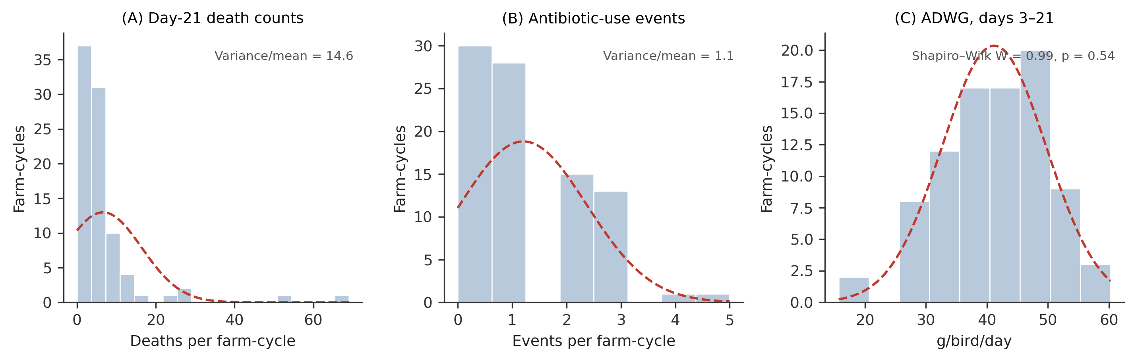
Figure 2. Distribution of the three primary outcomes across the 88 farm-cycles, with fitted normal curves (dashed red line). (A) Day-21 death counts show strong right skew and severe overdispersion. (B) Antibiotic-use events are low-count with a variance-to-mean ratio =1.1. (C) Average daily weight gain, days 3–21, is approximately normally distributed.
The fitted models were as follows. For the two count outcomes, cumulative mortality and antibiotic-use frequency, a Poisson model with a log link, a log offset and farm-clustered generalised estimating equations (GEE) was fitted:
log(μᵢⱼ) = β₀ + β₁·Vaccᵢⱼ + β₂·Periodᵢⱼ + log(Nᵢⱼ)
where μᵢⱼ is the expected count and Nᵢⱼ is the offset birds placed for mortality, and the number of seven-day observation windows for antibiotic use for farm i in production cycle j. An exchangeable working correlation structure accounted for the correlation between the two cycles within each farm, and robust (sandwich) standard errors were used. The exponentiated vaccination coefficient, exp(β₁), is the between-arm ratio of the modelled count per unit offset: a cumulative mortality ratio for mortality, and an incidence-rate ratio for antibiotic-use frequency.
The primary mortality estimate is a summary-measures statistic rather than a regression coefficient. Each farm contributes its own within-farm rate ratio and all farms are weighted equally:
log(RR) = (1/K) ∑ᵢ [ log((dᵢ,vac + 0.5) / Nᵢ,vac) − log((dᵢ,con + 0.5) / Nᵢ,con) ]
where dᵢ,vac and dᵢ,con are the cumulative deaths in the vaccinated and control cycle of farm i, Nᵢ,vac and Nᵢ,con the corresponding numbers of birds placed, K = 44 farms, and 0.5 is a continuity correction applied to each death count. Confidence intervals were derived from the t-distribution on the log scale with K − 1 degrees of freedom, and a paired Wilcoxon signed-rank test on the farm-level log rate ratios is reported alongside.
For average daily weight gain (ADWG), a linear mixed model with a random farm intercept was fitted:
ADWGᵢⱼ = β₀ + β₁·Vaccᵢⱼ + β₂·Periodᵢⱼ + uᵢ + εᵢⱼ
where uᵢ ~ N(0, σ²_farm) is the farm random intercept and εᵢⱼ ~ N(0, σ²_resid) the residual. Full coefficient estimates, with standard errors, 95% confidence intervals and p-values, are reported in the Results.
Antibiotic-use outcomes
Full-cycle antibiotic-use frequency through day 35 was analysed using a population-averaged Poisson generalised estimating equation (GEE) with a log link, an exchangeable working correlation structure, farm as the clustering unit and robust sandwich standard errors. The model included study arm and production period. Incidence-rate ratios (IRRs) with 95% confidence intervals are reported. A within-farm fixed-effects Poisson model was fitted as a supportive analysis.
Antibiotic use was analysed separately within the protocol-mandated restriction window (days 0–14) and the free-choice window (days 15–35), in which farmers in both arms could treat according to routine management. Within the restriction window, allocation almost completely separates the outcome, so an ordinary logistic model is not estimable; the paired comparison was made using McNemar's exact test, with Firth's penalised-likelihood logistic regression (20) reported as a supporting estimate. Within the free-choice window, a population-averaged logistic GEE was fitted, with McNemar's exact test reported alongside it. Antimicrobials were assigned to WHO highest-priority critically important classes (HPCIAs) on the basis of the recorded active ingredient rather than the product trade name, with common field misspellings of generic names resolved before classification; fluoroquinolones, macrolides and polymyxins were the only HPCIA classes recorded. HPCIA use was analysed on the same structure as overall use.
Mortality outcomes
Because the farm was the unit of randomisation and death counts were severely overdispersed, the pre-specified primary summary of the vaccination effect was the farm-weighted cluster-level rate ratio, a summary-measures analysis in which each farm contributes its own within-farm vaccinated-to-control mortality ratio with equal weight, irrespective of flock size. Confidence intervals were derived from the t-distribution on the log scale, and a paired Wilcoxon signed-rank test on farm-level log rate ratios was reported alongside. This estimator was selected in advance because it makes no distributional assumption about the farm-effect distribution and cannot be dominated by a small number of large, high-mortality farms.
Supportive and sensitivity analyses comprised a population-averaged Poisson GEE with an exchangeable working correlation, robust sandwich standard errors and fixed effects for vaccination and study period; a negative-binomial generalised linear model with cluster-robust standard errors; a negative-binomial model with farm fixed effects; and a longitudinal negative-binomial model with a time-varying population-at-risk offset, which accommodates the declining denominator directly. A naive Poisson model, which accommodates neither the clustering of cycles within farms nor the overdispersion of the death counts, is reported solely to document its rejection. All mortality models were fitted at the day-21 primary endpoint and repeated at day 28 as a sensitivity analysis. Mortality was not evaluated at day 35, because progressive harvest from day 21 leaves the population at risk neither fixed nor comparable between arms.
Growth outcomes
The primary growth outcome was average daily weight gain from day 3 to day 21, calculated as the difference between mean body weight at day 21 and mean body weight at day 3 divided by 18 days, with the farm-cycle as the unit of analysis. ADWG was analysed using a linear mixed-effects model with study arm and production period as fixed effects and farm as a random intercept, fitted by restricted maximum likelihood. Average daily weight gain from day 3 to day 28 was analysed as a sensitivity outcome using the same specification. Interval-specific ADWG was calculated for days 3–14 and days 14–21 and analysed on the same structure.
Clinical signs, adherence and acceptability
Clinical signs were analysed as the number of monitoring visits within each farm-cycle at which one or more clinical signs were recorded, using a Poisson GEE with farm as the clustering unit and the logarithm of the number of valid monitoring visits as an offset. Vaccine administration was documented for each intervention cycle, including the date of administration, reconstituted volume and number of live birds present. The administered dose per bird was compared with the protocol-defined target, and doses within ±20% of the target were classified as adherent; doses below and above this range were classified as under-dosed and over-dosed respectively. Adherence to the antibiotic-withholding protocol was defined as no recorded antibiotic use during the restriction period. Mortality during days 5–14 was compared between flocks receiving doses within and outside the acceptable dosing range as an exploratory safety assessment. Exit-questionnaire responses were summarised descriptively.
Missing data and post-harvest measurements
The primary mortality analysis included farm-cycles with valid cumulative mortality data through day 21, and the primary growth analysis those with valid body-weight measurements at both endpoints. Missing outcome measurements were not imputed. Body-weight values recorded as zero were treated as missing only where source records confirmed that zero indicated that a bird had not been weighed rather than a true measurement. Measurements unavailable because marked birds had been sold were classified as structurally missing due to harvesting; the day 3–28 growth analysis was therefore treated as a sensitivity analysis. Day-28 weights were available for 80 of 88 farm-cycles. Six day-35 monitoring visits were not completed, five of them in vaccinated cycles; a single antibiotic-use event was recorded at day 35 across the whole trial, so the effect of this imbalance on the antibiotic-use estimate is negligible. All exclusions, corrections and outcome reclassifications were documented before inferential analyses were finalised.
Model diagnostics
Goodness-of-fit and dispersion diagnostics for all primary models were examined; the outcome distributions are shown in Figure 2, and the full diagnostics are reproducible from the archived analysis code. For count models, the Pearson χ²/df statistic and the variance-to-mean ratio were used to assess overdispersion, and simulation-based residual diagnostics were conducted. For mixed-effects models, convergence was assessed using optimizer convergence codes and positive-definiteness of the Hessian, and random-effect variances and model singularity were examined. For GEE models, convergence status, the number of clusters and robust sandwich standard errors were reviewed. For linear mixed-effects models, residual normality and homoscedasticity were assessed graphically and by the Shapiro–Wilk test.
Software
All analyses were performed in R version 4.3.3 (R Foundation for Statistical Computing, Vienna, Austria). Generalised estimating equations were fitted with geepack, negative-binomial models with MASS, linear mixed models with lme4 and lmerTest, cluster-robust (sandwich) standard errors with sandwich and lmtest, and Firth's penalised logistic regression with logistf. Figures were produced with ggplot2. Package versions were geepack 1.3.10, MASS 7.3-60, lme4 1.1-35.1, lmerTest 3.1-3, sandwich 3.1-0, lmtest 0.9-40, logistf 1.26.1 and ggplot2 3.4.4.
Results
Participant flow, analysis population and baseline comparability
Of 110 women-owned smallholder broiler farms assessed at baseline, 52 were enrolled and randomised. Five farms were lost to follow-up after the first production cycle and did not begin the second. A further three farms completed both cycles but were excluded before analysis for pre-specified scientific and safety reasons. Forty-four farms (84.6%) were therefore analysed, 24 in Arusha and 20 in Kilimanjaro contributing 88 farm-cycles and 28,156 birds placed (14,322 in control and 13,834 in vaccinated cycles). Twenty-four farms were allocated to the vaccinate-then-control sequence and 20 to the control-then-vaccinate sequence. The two sequence groups were comparable at enrolment in flock size, day-3 body weight and regional distribution (Table 1).
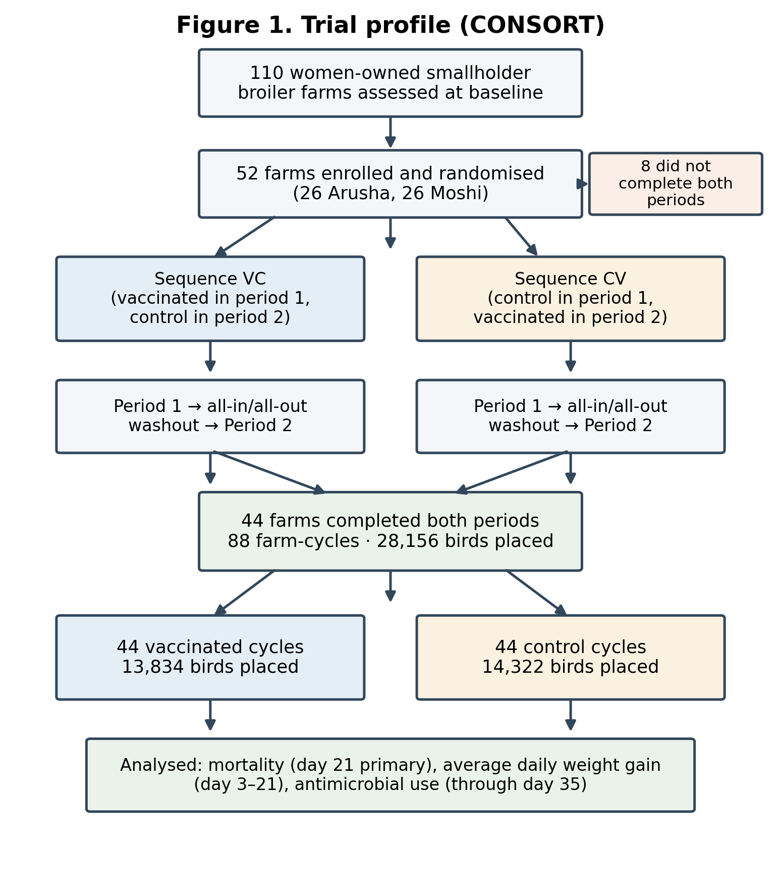
Figure 1. CONSORT flow diagram of farm enrolment, randomisation, follow-up and analysis in the Poulvac® E. coli vaccine cluster-randomised crossover trial.

Table 1. Analysis population and baseline comparability by treatment sequence
Characteristic | Vaccinated–Control (n = 24 farms) | Control–Vaccinated (n = 20 farms) | Total (N = 44) | p
Farms included in paired analysis, n | 24 | 20 | 44 | —
Farm-cycles contributed, n | 48 | 40 | 88 | —
Vaccinated farm-cycles, n | 24 | 20 | 44 | —
Control farm-cycles, n | 24 | 20 | 44 | —
Flock size at enrolment, mean birds | 289.5 | 349.6 | — | 0.14
Day-3 body weight, mean g/bird | 67.2 | 68.1 | — | 0.70
Region, Arusha : Kilimanjaro | — | — | 24 : 20 | 0.36
Comparisons are between treatment sequences, not study arms. Flock size and day-3 weight compared by t-test; regional distribution by Fisher's exact test.
Farm and farmer characteristics
All 44 participating farms were owned and operated by women, and all had access to electricity, enclosed housing with concrete flooring and night lighting, and undertook litter change, cleaning and disinfection between cycles (Table 2). Median farmer age was 52 years and median poultry-keeping experience was 5.5 years. No characteristic differed significantly between regions.
Table 2. Farm and farmer characteristics (n = 44 farms)
Characteristic | All farms | Arusha (n = 24) | Kilimanjaro (n = 20) | p
Farmer age, years, median (IQR) | 52 (45–60) | — | — | 0.47
Poultry-keeping experience, years, median (IQR) | 5.5 (4–12) | — | — | 0.76
Female operator | 44 (100%) | 24 (100%) | 20 (100%) | 1.00
Owner is primary worker | 40 (91%) | 21 (88%) | 19 (95%) | 0.61
Family assists daily | 29 (66%) | 19 (79%) | 10 (50%) | 0.06
Hired labour used | 13 (30%) | 5 (21%) | 8 (40%) | 0.20
Farmer-group member | 17 (39%) | 11 (46%) | 6 (30%) | 0.36
Received training | 17 (39%) | 12 (50%) | 5 (25%) | 0.12
Access to electricity | 44 (100%) | 24 (100%) | 20 (100%) | 1.00
Access to clean water | 43 (98%) | 23 (96%) | 20 (100%) | 1.00
Enclosed housing | 44 (100%) | 24 (100%) | 20 (100%) | 1.00
Concrete flooring | 44 (100%) | 24 (100%) | 20 (100%) | 1.00
Night lighting | 44 (100%) | 24 (100%) | 20 (100%) | 1.00
Litter changed between cycles | 44 (100%) | 24 (100%) | 20 (100%) | 1.00
House cleaned and disinfected between cycles | 44 (100%) | 24 (100%) | 20 (100%) | 1.00
Downtime ≥ 2 weeks between cycles | 41 (93%) | 21 (88%) | 20 (100%) | 0.24
Unusual events during the study (all flooding) | 3 (7%) | 3 (13%) | 0 | 0.24
Newcastle disease vaccination, vaccinated cycles | 38 (86%) | — | — | 0.69
Gumboro (IBD) vaccination, vaccinated cycles | 31 (70%) | — | — | 1.00
Values are n (%) unless stated. Between-region comparisons by Fisher's exact test for categorical variables and the Mann–Whitney U test for age and experience. Routine vaccination proportions are compared between study arms by McNemar's exact test .
Intervention implementation and adherence
Adherence to the intervention was high. Poulvac® E. coli was recorded as administered on day 5 across all 44 vaccinated cycles, with a median reconstituted volume of 0.6 mL (interquartile range 0.4–0.63 mL), consistent with the small-flock dosing protocol. Antibiotics were recorded during the restriction window in 1 of 44 vaccinated cycles, indicating 97.7% adherence to the withholding protocol. No safety signal attributable to vaccination was observed.
The vaccination-by-period interaction was non-significant for every outcome — mortality (p = 0.15), antibiotic-use frequency (p = 0.67) and average daily weight gain (p = 0.45) — and a sequence-group comparison of farm-total mortality was likewise non-significant (p = 0.52), consistent with the absence of a carryover effect between production cycles. A period effect independent of allocation was nonetheless present and was retained in all models: antibiotic use was lower in the second cycle (IRR 0.61, 95% CI 0.47–0.79; p<0.001) and weight gain higher (+3.4 g/bird/day, 95% CI +1.1 to +5.8; p = 0.004). The crossover design controls for this.
Multivitamin use
Multivitamin sachets were supplied by the study to 43 of 44 vaccinated cycles and, on request, to 6 of 44 control cycles. At cycle level, use was near-universal in both arms during the restriction window (44 of 44 vaccinated versus 42 of 44 control). Recorded use at visit level was higher in vaccinated cycles during the restriction window (120 of 132 visits, 90.9%, versus 103 of 132, 78.0%). Recording varied markedly between research assistants, from 33% to 100% of control-cycle visits within the same window, and multivitamin recording tracked antibiotic recording closely within visits. Eight of the antibiotic products administered in control cycles named vitamins or minerals among their ingredients, so vitamin administration was in part a component of the antibiotic events themselves rather than a separate exposure.
Antibiotic use
Full-cycle antibiotic-use frequency
Across the full production cycle, 23 antibiotic-use events were recorded in vaccinated cycles compared with 88 in control cycles, a reduction of approximately 74% (IRR 0.25, 95% CI 0.18–0.33; p<0.001; Table 3). A within-farm fixed-effects Poisson model gave a closely similar estimate (IRR 0.24, 95% CI 0.15–0.40; p<0.001), and the counts showed no evidence of overdispersion (Pearson χ²/df = 0.67), supporting the Poisson specification. Antibiotics were classified by active ingredient; the events comprised fluoroquinolones (26 control, 5 vaccinated), macrolides (16 control, 8 vaccinated) and colistin (one event, in a vaccinated cycle during the free-choice window); one event named both a fluoroquinolone and a macrolide. Events by antimicrobial class and arm are given in Supplementary Table S2.
Five recorded events were reclassified out of the antibiotic-use outcome after being identified as non-antibacterial agents: three cases of amprolium, one of toltrazuril (both anticoccidials), and one of ambroxonil (a mucolytic respiratory treatment). Because all five misclassifications occurred exclusively during control cycles, keeping them in the dataset would have artificially overstated antibiotic overuse within the control group. Counting every record rather than only those reclassified out, an anticoccidial was administered in 5 of 44 control and 2 of 44 vaccinated cycles (McNemar's exact p = 0.38); in the two vaccinated cycles it was co-administered with an antibiotic, so those events correctly remained within the outcome.
Restriction-period antibiotic use
The temporal pattern of antibiotic use is shown in Figure 3, with window-specific analyses presented in Table 3. During the protocol-defined restriction period (days 0–14), antibiotic use was recorded in 1 of 44 vaccinated cycles (2.3%) compared with 33 of 44 control cycles (75.0%).
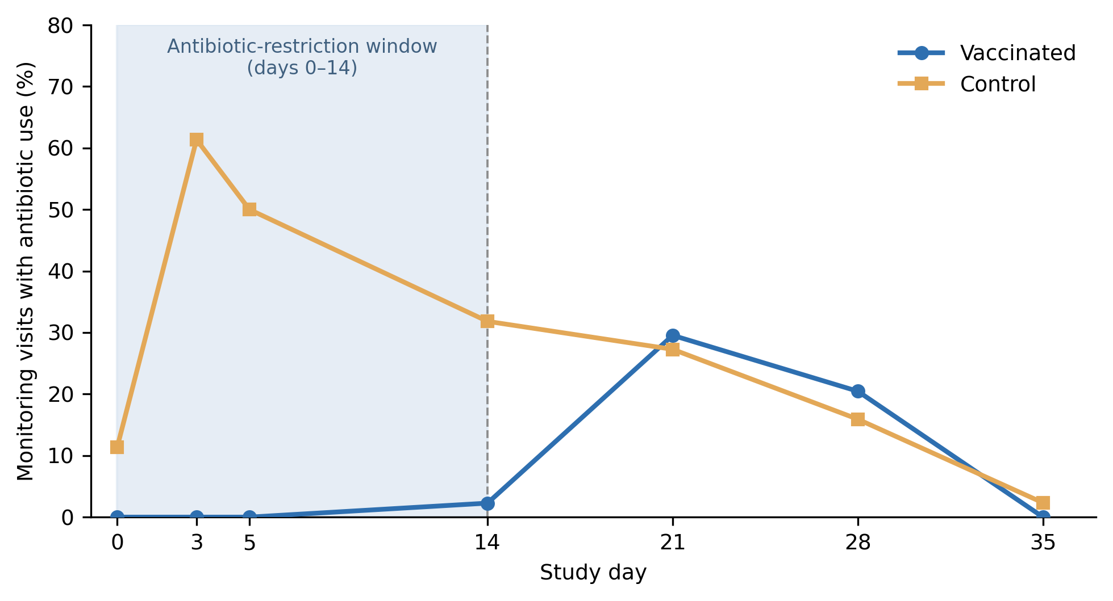
Figure 3. Antibiotic use across the production cycle by study arm. Percentage of monitoring visits with recorded antibiotic use, by study day and study arm. The shaded area indicates the protocol-defined restriction window (days 0–14), during which antibiotics were withheld in vaccinated cycles but remained available in control cycles. After day 14, farmers in both arms could administer antibiotics according to routine management.
Table 3. Antibiotic use by study arm across the full production cycle and protocol-defined periods,
with corresponding effect estimates
Analysis | Model | Vaccinated | Control | Effect (95% CI) | p
Full cycle, use-events per 7-day window | GEE Poisson | 23 events | 88 events | IRR 0.25 (0.18–0.33) | <0.001
Full cycle supportive analysis | Within-farm FE Poisson | — | — | IRR 0.24 (0.15–0.40) | <0.001
Restriction window, days 0-14,any antibiotic use | Firth logistic | 1/44 (2.3%) | 33/44 (75.0%) | OR 0.012 (0.002–0.070) | <0.001
Free-choice window, days 15–35, any use | GEE logistic | 20/44 (45.5%) | 16/44 (36.4%) | OR 1.38 (0.58–3.29) | 0.47
Free-choice window, unreclassified counts | GEE logistic | 20/44 (45.5%) | 19/44 (43.2%) | OR 1.02 (0.43–2.42) | 0.97
HPCIA events, full cycle | GEE Poisson | 14 events | 41 events | IRR 0.31 (0.18–0.52) | <0.001
HPCIA events, restriction window | Descriptive | 0 events | 30 events | — | —
HPCIA events, free-choice window | GEE Poisson | 14 events | 11 events | IRR 1.18 (0.58–2.40) | 0.64
CI, confidence interval; FE, fixed effects; GEE, generalised estimating equations; HPCIA, WHO highest-priority critically important antimicrobial; IRR, incidence-rate ratio; OR, odds ratio. HPCIAs were assigned by recorded active ingredient, not product trade name. Day-0 records are retained: farms operated all-in/all-out with downtime between cycles, so an antibiotic recorded at the placement visit refers to administration to the incoming flock. The unreclassified free-choice row is shown to document the sensitivity of that window to the classification rule.
Post-restriction antibiotic use
During the free-choice window (days 15–35), when both arms could treat according to routine management, use did not differ between arms: 20 of 44 vaccinated versus 16 of 44 control cycles, and 22 versus 20 use events (OR 1.38, 95% CI 0.58–3.29; p = 0.47). The point estimate lies above unity, but the confidence interval is wide and the direction is not robust to classification: four of the five non-antibacterial events reclassified out of the outcome fell within this window, and all were in control cycles, so on the unreclassified counts the same comparison was 20 versus 19 cycles (OR 1.02, 95% CI 0.43–2.42; p = 0.97; Table3). There was no significant difference in antibiotic use between study arms after the restriction period.
WHO highest-priority critically important antimicrobials
Ten of 44 control cycles and 4 of 44 vaccinated cycles recorded any HPCIA use (IRR 0.31, 95% CI 0.18–0.52; p < 0.001; Table 3). During the restriction period, no HPCIA events were recorded in vaccinated cycles compared with 30 in control cycles. During the free-choice period, however, HPCIA use was similar between groups (14 vs 11 events; IRR 1.18, 95% CI 0.58–2.40; p = 0.64; Table 3).
Mortality
Day-21 mortality
Cumulative mortality to day 21 was 2.4% of birds placed in control cycles and 1.7% in vaccinated cycles. Mortality was lower in vaccinated cycles under every specification, but the reduction did not reach statistical significance in any model that respected the design (Table 4, Figure 4). Under the primary model, the farm-weighted cluster-level rate ratio was 0.95 (95% CI 0.73–1.23; p = 0.70); a paired Wilcoxon signed-rank test on farm-level log rate ratios agreed (p = 0.95).
Why the primary model was chosen
The divergence between the crude bird-weighted estimate (RR 0.69) and the farm-weighted estimate (RR 0.95) reflects the influence of a small number of large, high-mortality farms, whose disproportionate weight the summary-measures approach is designed to neutralise. Three farms, 6.8% of the sample and 8.4% of the birds contributed 30.1% of all day-21 deaths, and in each the high-mortality cycle fell in the control arm; omitting the single most influential farm moves the crude estimate from 0.69 to 0.81. Death counts were severely overdispersed at the day-21 endpoint (Pearson χ²/df = 12.0; variance-to-mean ratio 14.6; maximum 69 deaths against a mean of 6.6; 3.4% zero cycles), and flock size ranged from 200 to 1,010 birds per cycle. A naive Poisson model, which accommodates neither the overdispersion nor the clustering of cycles within farms, was the only specification returning a significant result (RR 0.69, 95% CI 0.59–0.82; p<0.001); it is reported in Table 4 solely to document why it was rejected. All 23 model fits (13 specifications across the day-21 and day-28 endpoints) are given in Supplementary Table S3. Cumulative mortality by study day is shown in Supplementary Figure S1: the arms are indistinguishable to day 14 and separate only between day 14 and day 21. Farm-level mortality and the influence of individual farms are shown in Supplementary Figures S2 and S3.
Sensitivity analyses
The day-28 sensitivity analysis was concordant (RR 0.89, 95% CI 0.68–1.15; p = 0.35), as were the population-averaged and conditional count models (full coefficients of the population-averaged Poisson GEE model are given in Table 5). The estimates fall into two families: models that pool information across farms return rate ratios between 0.69 and 0.78, while models in which each farm serves as its own control return rate ratios close to 0.95. Because the farm was the unit of randomisation and every farm supplied both a vaccinated and a control cycle, the within-farm contrast is the estimand of interest, and the between-farm family is reported for completeness only.
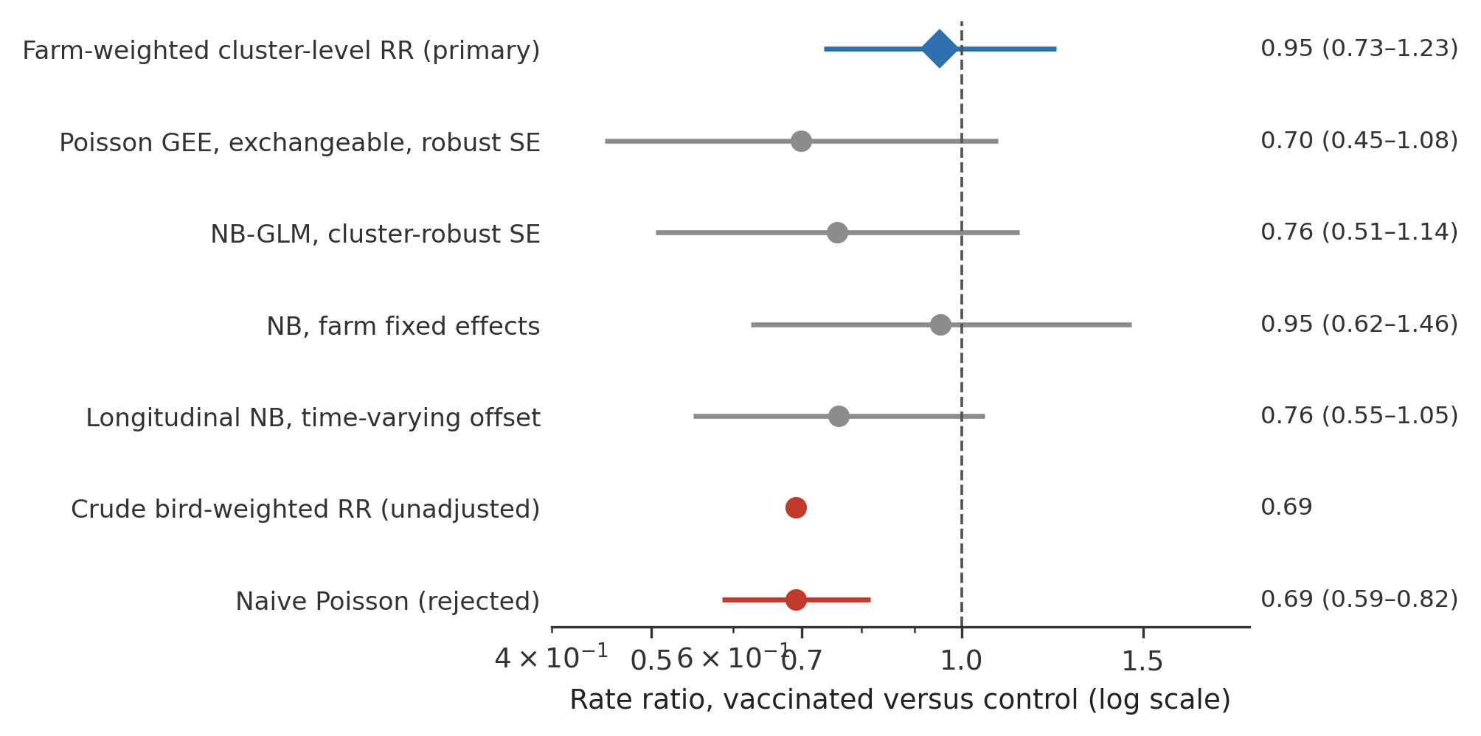
Figure 4. Day-21 mortality rate ratios across model specifications, vaccinated versus control. The primary farm-weighted cluster-level estimate is shown in blue; supportive and sensitivity specifications in grey; rejected specifications in red. The vertical dashed line marks the null. Note the logarithmic x-axis.
Table 4. Mortality rate ratios at day 21 and day 28
Model | Day 21 (primary) | p | Day 28 (sensitivity) | p
Farm-weighted cluster-level RR (primary) | 0.95 (0.73–1.23) | 0.70 | 0.89 (0.68–1.15) | 0.35
Poisson GEE, exchangeable, robust SE | 0.70 (0.45–1.08) | 0.11 | 0.70 (0.48–1.04) | 0.07
NB-GLM, cluster-robust SE | 0.76 (0.50–1.14) | 0.18 | 0.74 (0.51–1.07) | 0.11
NB, farm fixed effects | 0.95 (0.62–1.46) | 0.83 | — | —
Longitudinal NB, time-varying offset | 0.76 (0.55–1.05) | 0.10 | — | —
Crude bird-weighted RR (unadjusted) | 0.69 | — | 0.69 | —
Naive Poisson (rejected) | 0.69 (0.59–0.82) | <0.001 | 0.69 (0.59–0.79) | <0.001
Values are rate ratios (95% CI), vaccinated versus control. Offset = natural logarithm of birds placed. The naive Poisson model ignores both the clustering of cycles within farms and the substantial overdispersion of the death counts, and is shown only to document its rejection. Mortality was not evaluated at day 35 because progressive harvest from day 21 leaves the population at risk neither fixed nor comparable between arms. GEE, generalised estimating equations; NB, negative binomial; RR, rate ratio; SE, standard error.
Table 5. Day-21 mortality model coefficients (Poisson GEE, supportive analysis)
Term | β | SE | IRR (95% CI) | p
Intercept | −3.705 | 0.232 | 0.025 (0.016–0.039) | <0.001
Vaccinated (versus control) | −0.358 | 0.224 | 0.70 (0.45–1.08) | 0.11
Period 2 (versus period 1) | −0.023 | 0.252 | 0.98 (0.60–1.60) | 0.93
Offset = natural logarithm of birds placed; estimated working correlation α = 0.35. β, regression coefficient on the log scale; IRR, incidence-rate ratio; SE, standard error.
Growth
Primary average daily weight gain
Average daily weight gain over days 3 to 21 did not differ between arms: −1.67 g/bird/day (95% CI −3.98 to +0.65; p = 0.16; Table 6). Farm clustering was substantial, the intraclass correlation coefficient was 0.57, with a farm standard deviation of 6.31 g/bird/day against a residual standard deviation of 5.51 g/bird/day — confirming that a model treating the two cycles per farm as independent would understate the standard errors. Residuals were consistent with normality (Shapiro–Wilk W = 0.98; p = 0.22). The days 3–28 sensitivity analysis agreed in both direction and magnitude (−1.6 g/bird/day, 95% CI −3.9 to +0.7; p = 0.17; n = 80 farm-cycles).
Interval-specific growth
Disaggregation by growth window (Figure 5) nonetheless reveals a transient early lag: over days 3–14, which coincides with vaccination and the antibiotic-restriction period, vaccinated birds gained significantly less weight than controls (−2.80 g/bird/day, 95% CI −4.40 to −1.20; p = 0.001). This deficit resolved over days 14–21 (+0.10 g/bird/day, 95% CI −4.60 to +4.70; p = 0.98), leaving no difference at the day-21 primary endpoint. Mean body weight by study day and arm is shown in Supplementary Figure S4. There was therefore no growth penalty at harvest, but the early lag is a real finding rather than noise and is considered further in the Discussion.
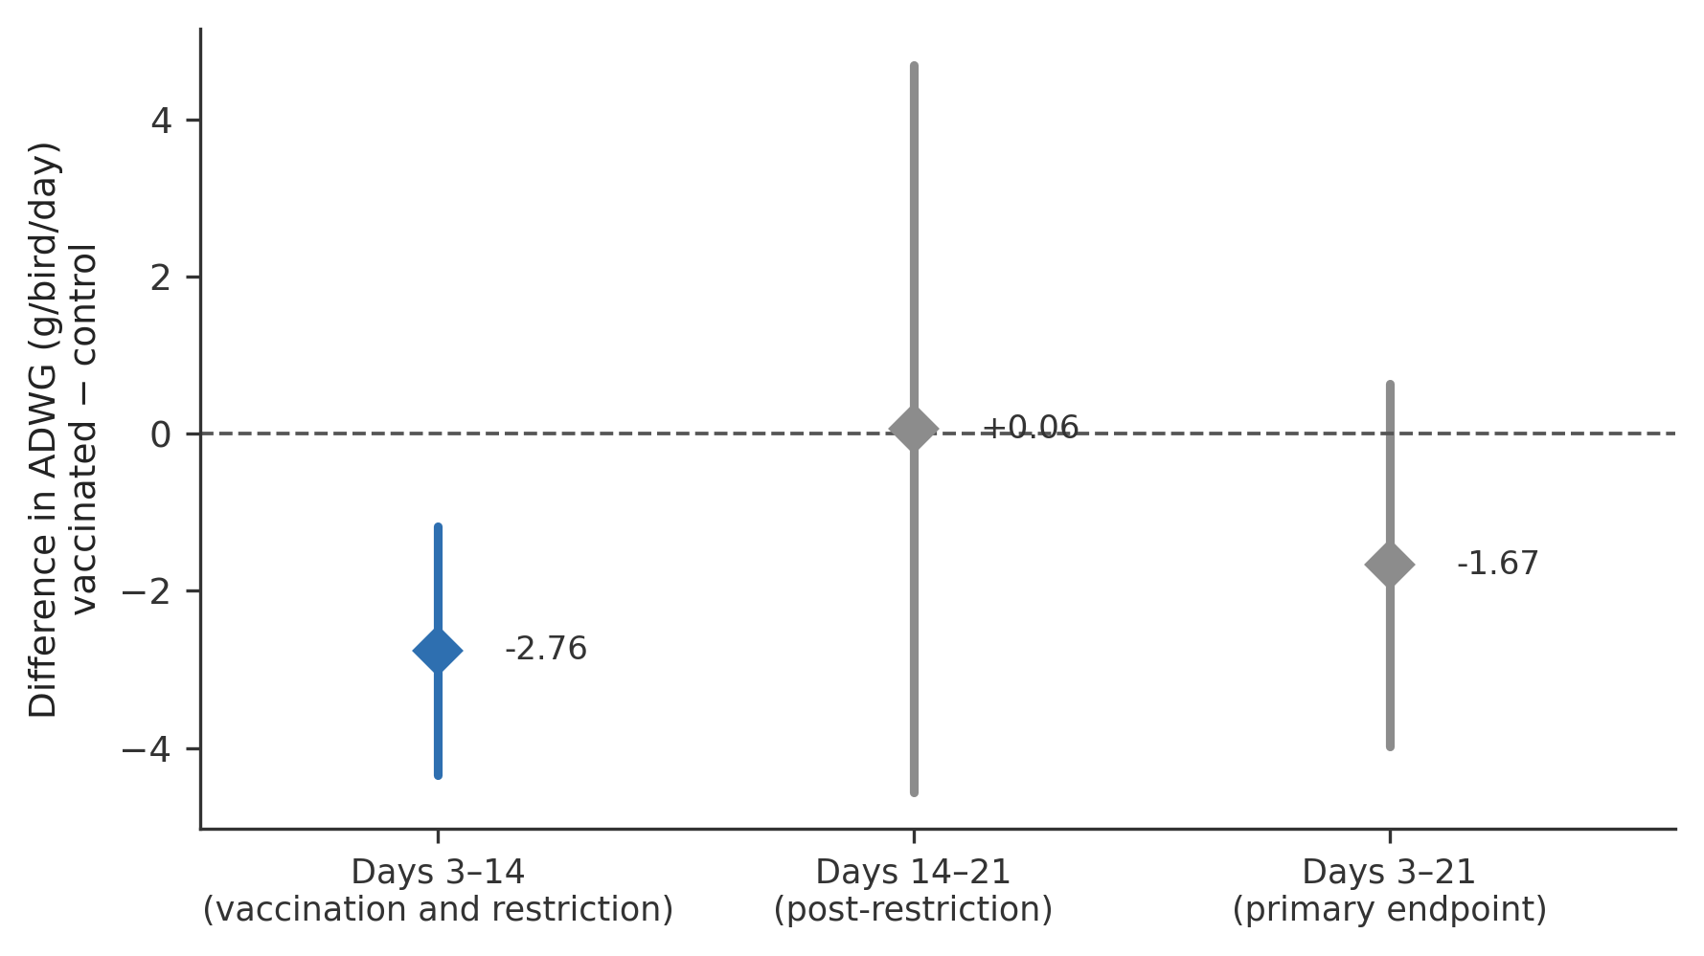
Figure 5. Difference in average daily weight gain, vaccinated minus control, by growth window. Points are adjusted mean differences from linear mixed-effects models; vertical bars are 95% confidence intervals. The horizontal dashed line marks no difference.
Table 6. Average daily weight gain model coefficients, days 3–21 (linear mixed model)
Term | β (g/bird/day) | SE | 95% CI | p
Intercept | 40.29 | 1.42 | 37.51 to 43.07 | <0.001
Vaccinated (versus control) | −1.67 | 1.18 | −3.98 to +0.65 | 0.16
Period 2 (versus period 1) | +3.44 | 1.18 | +1.13 to +5.75 | 0.004
n = 88 farm-cycles from 44 farms. Farm SD = 6.31 g/bird/day; residual SD = 5.51 g/bird/day; ICC = 0.57. Bird weights recorded as 0 g were excluded as denoting birds not weighed rather than birds of zero mass. CI, confidence interval; ICC, intraclass correlation coefficient; SD, standard deviation; SE, standard error.
Table 6b. Interval-specific and sensitivity analyses of average daily weight gain
Analysis | n farm-cycles | Mean difference (95% CI) | p
Days 3–21 (primary) | 88 | −1.67 (−3.98 to +0.65) | 0.16
Days 3–14 | 88 | −2.80 (−4.40 to −1.20) | 0.001
Days 14–21 | 88 | +0.10 (−4.60 to +4.70) | 0.98
Days 3–28 (sensitivity) | 80 | −1.60 (−3.90 to +0.70) | 0.17
Mean differences are vaccinated minus control, in g/bird/day. The reduced number of farm-cycles in the days 3–28 analysis reflects marked birds no longer available for weighing at day 28 following harvest.
Clinical signs
Sick birds were recorded at 41 visits in vaccinated cycles and 42 visits in control cycles, with no difference between arms (IRR 0.95, 95% CI 0.57–1.57; p = 0.84).
Vaccine dose adherence
Dose adherence under field conditions was strong. Across all 44 vaccinated flocks, 40 (91%) received a dose within ±20% of the per-bird protocol target (median dose ratio 1.00); the four out-of-range flocks comprised one under-dosed and three over-dosed flocks (Figure 6). Mortality during days 5–14 averaged 0.93% across vaccinated cycles and was no higher in the four out-of-range flocks than in the 40 dosed within the acceptable range (0.37% versus 0.98%; Mann–Whitney p = 0.17), indicating that drinking-water administration is operationally feasible for smallholder broiler farmers given appropriate technical support. No apparent vaccination-related adverse event was recorded.
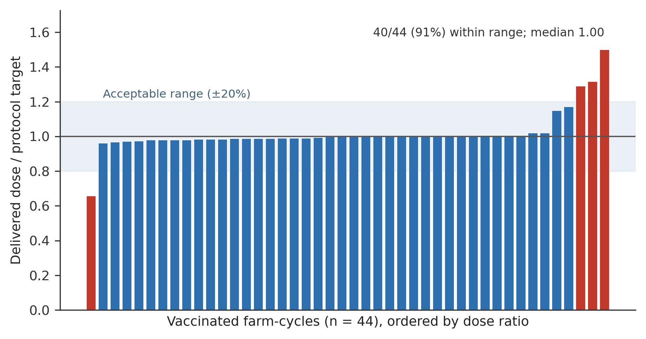
Figure 6. Vaccine dose adherence across the 44 vaccinated farm-cycles. Bars show the delivered dose as a proportion of the per-bird protocol target, ordered by dose ratio. The shaded band marks the acceptable range (±20% of target); bars outside the band are shown in red.
Post-mortem findings
Post-mortem submissions to the Tanzania Veterinary Laboratory Agency were dominated by Escherichia coli, with gross findings of colibacillosis and yolk-sac infection/omphalitis. Several early deaths were attributable to hatchery-origin omphalitis established before or around day 5. Colibacillosis attributable to E. coli also occurred in an unvaccinated control flock, indicating field rather than vaccine origin.
Farmer perceptions and reported challenges
Exit-questionnaire responses are summarised in Table 7. Most farmers perceived the vaccinated cycle as having fewer deaths (82%) and better growth (77%), and willingness to pay for the vaccine (93%) and to recommend it (95%) were near-universal. Asked which phase they preferred overall, most rated the two equally (45%) or favoured the vaccinated phase (39%); 11% preferred the control phase. These are perceptions rather than measurements, and they diverge from the trial data, in which neither mortality nor growth differed significantly between arms.

Table 7. Exit questionnaire responses (n = 44 farms)
Item | Yes | Don't know | No
Perceptions of the vaccinated cycle
Fewer deaths than the control cycle | 36 (82%) | 4 (9%) | 4 (9%)
Birds grew better than in the control cycle | 34 (77%) | 8 (18%) | 2 (5%)
Would be willing to pay for the vaccine | 41 (93%) | 3 (7%) | 0
Would recommend the vaccine to others | 42 (95%) | 2 (5%) | 0
Production phase preferred
Both phases equally | 20 (45%)
Vaccinated phase | 17 (39%)
Control phase | 5 (11%)
Don't know | 2 (5%)
Challenges reported (multiple response)
High feed costs | 26 (59%)
Disease outbreak | 12 (27%)
Poor bird growth | 11 (25%)
Low market prices | 9 (20%)
Mortality | 6 (14%)
Poor chick quality / poor feed quality / extreme weather | 4 (9%) each
Vaccine-related / treatment-related difficulties | 3 (7%) each
Other (mainly lack of reliable market access) | 11 (25%)
Lack of electricity | 1 (2%)
No challenges reported | 7 (16%)
Values are number of farms (%) among the 44 farms contributing to the paired analysis. Perception items were recorded on a yes / don't know / no basis. Challenge items were multiple-response, so percentages sum to more than 100%. Feed shortage, lack of water, labour shortages and theft or predation were not reported by any farm.
Acceptability, farmer-reported disease and production context
Acceptability of the intervention was high. Across the end-of-cycle monitoring records, 70 of 82 responses (85.4%) reported satisfaction with the study cycle and 81 of 82 (98.8%) indicated willingness to continue. In the exit questionnaire, all 44 farmers reported satisfaction with research-assistant support and willingness to take part in a follow-on study, and 43 of 44 (98%) reported having understood the study protocol. Fewer than half (20 of 44, 45%) were aware before the study that routine prophylactic antibiotic use is discouraged, which is relevant to the interpretation of the baseline prophylaxis rate observed in control cycles.
Farmer-reported clinical signs, compared within farms between the vaccinated and control cycle, were directionally lower in vaccinated cycles for every category but reached conventional significance for none (Table 8). The largest contrast was for respiratory disease, reported in 20 of 44 vaccinated cycles versus 28 of 44 control cycles (McNemar's exact p = 0.06). This is consistent in direction with the perception data but, like the field-recorded clinical-sign counts, does not constitute evidence of a vaccine effect on clinical disease.
Production context was comparable between the two cycles. Chick quality was rated good in 40 of 44 cycles in each arm, feed quality in 40 of 44 vaccinated and 43 of 44 control cycles (p = 0.38), and chicks were placed within 48 hours of hatch in 31 of 44 cycles in each arm. The same feed brand was used across both cycles on 33 of 44 farms (75%). No farm reported beginning harvest before day 21 in either cycle, supporting the choice of day 21 as the primary endpoint. Broader economic context was less favourable: 31 of 44 farmers (70%) reported selling birds at their desired weight and having an established market, but only 21 of 44 (48%) reported that their price expectation was met, 32 of 44 (73%) that income met household needs, and just 9 of 44 (20%) reported access to credit. High feed costs were the most frequently reported challenge (Table 7).
Table 8. Farmer-reported clinical signs and production context, within-farm comparison by study arm (n = 44 farms)
Item | Vaccinated cycle | Control cycle | Discordant pairs | p
Farmer-reported clinical signs
Respiratory disease | 20 (45%) | 28 (64%) | 6 : 14 | 0.06
Gastrointestinal disease | 19 (43%) | 23 (52%) | 8 : 12 | 0.42
Stunted growth | 9 (20%) | 11 (25%) | 5 : 7 | 0.77
Sudden deaths | 4 (9%) | 6 (14%) | 2 : 4 | 0.75
Swollen eyes | 0 | 3 (7%) | 0 : 3 | 0.25
Production context
Chick quality rated good | 40 (91%) | 40 (91%) | 2 : 2 | 1.00
Feed quality rated good | 40 (91%) | 43 (98%) | 1 : 4 | 0.38
Chicks placed within 48 h of hatch | 31 (70%) | 31 (70%) | 4 : 4 | 1.00
Harvest began before day 21 | 0 | 0 | 0 : 0 | 1.00
Values are number of farms (%). Each farm contributes one vaccinated and one control cycle; comparisons are McNemar's exact test on discordant pairs, reported as vaccinated-only : control-only. Items were recorded by production phase in the exit questionnaire and mapped to study arm using each farm's allocated sequence. These are farmer-reported recollections at the end of the study and are subject to recall bias; they are reported alongside, not in place of, the field-recorded clinical-sign counts.
Discussion
In this cluster-randomised crossover trial on 44 women-owned smallholder broiler farms in northern Tanzania, a vaccine-anchored stewardship package reduced full-cycle antibiotic-use frequency by approximately 74%, and no use of antimicrobials that the World Health Organisation classifies as highest-priority critically important for human medicine was recorded in vaccinated cycles during the restriction window (4,5). This reduction occurred without evidence of increased mortality or a sustained reduction in growth at the primary endpoint. To our knowledge, this is among the first randomised evaluations of Poulvac® E. coli in a smallholder broiler system in sub-Saharan Africa and one of the first to disaggregate antibiotic use during and after a protocol-defined withholding period.
That disaggregation is the study's central methodological contribution, and it constrains what can be claimed. Because the live vaccine cannot be administered concurrently with antibiotics, vaccination and the mandated withholding protocol were perfectly confounded across the full cycle; the full-cycle estimate is therefore an intervention-package effect. Almost the entire reduction sits within the restriction period. Use of critically important antimicrobials follows an identical pattern. It is tempting to read the null free-choice window as evidence that the saving was attributable to withholding rather than to the vaccine, but that inference is not supported. The 36 events is underpowered, and its confidence interval is compatible with a substantial effect in either direction. Perfect confounding blocks attribution in both directions equally. What the trial establishes is that the package works; what it cannot establish is which component is doing the work.
The HPCIA classes involved, fluoroquinolones, macrolides, and colistin (a single event). These antibiotics are precisely those for which resistance has already been documented in Escherichia coli isolated from broilers in Arusha and neighbouring regions of Tanzania (11), and which are implicated in the circulation of resistant organisms between poultry, people and the environment (10). A 74% reduction in exposure to this group of compounds is a substantial stewardship gain irrespective of which component of the package produced it.
Clinical disease was no less frequent in vaccinated flocks, and the mortality reduction, while consistently protective in direction across every specification, did not reach significance. The trial therefore demonstrates that a structured withholding protocol, made acceptable and safe by vaccination, substantially reduces antibiotic use in this setting; it does not demonstrate a vaccine-specific reduction in the need for treatment. This distinction matters, and it does not diminish the finding. Much of the antimicrobial use displaced here was prophylactic rather than therapeutic administered in the first two weeks of the cycle, before disease was evident, as insurance against anticipated risk. That is precisely the use category that stewardship frameworks target, and precisely the category that a preventive intervention can displace without leaving farmers exposed. The free-choice window shows what happened when birds did become sick: farmers in both arms treated at a comparable rate, and vaccination neither prevented that need nor obstructed the response. That antibiotics remain of value once colibacillosis is established is not in dispute (9); what this trial suggests is that their routine prophylactic use in the first two weeks can be withdrawn without an observable production penalty when a preventive alternative and field support are in place.
An intervention that removes prophylactic use while leaving therapeutic access intact is doing what a stewardship intervention should do (12). The one cost the intervention did impose was transient. Disaggregated by growth window, vaccinated birds gained significantly less weight than controls over days 3–14, the interval that contains both vaccination and the antibiotic-restriction period. The deficit resolved completely over days 14–21, leaving no difference at the day-21 primary endpoint or at day 28. The most plausible explanation is the antibiotic restriction rather than the vaccine. Previous studies have shown that antibiotic use can provide a short-term growth advantage in broilers (21,22). In this study, control flocks received prophylactic antibiotics during the first two weeks, whereas vaccinated flocks initially grew more slowly but overcame this deficit after the restriction ended. Together with the absence of any difference in clinical disease, this pattern is more consistent with compensatory growth than with vaccine-induced impairment. Nevertheless, the temporary reduction in growth is practically important. Farmers adopting this strategy should be advised that vaccinated birds may appear slightly smaller during the restriction period but are expected to recover before harvest. Stewardship programmes should acknowledge this short-term effect, as farmers may lose confidence if early differences in growth are not clearly explained.
Mortality findings were broadly reassuring but imprecise. Cumulative mortality through day 21 was 1.7% during vaccinated cycles and 2.4% during control cycles, corresponding to a farm-weighted rate ratio of 0.95. Every specification that respected the paired cluster design was directionally favourable to vaccination and none reached significance, and the day-28 sensitivity analysis was concordant. The choice of primary model materially affects the point estimate: specifications that pool information across farms return rate ratios near 0.70, while specifications in which each farm serves as its own control return rate ratios near 0.95. The divergence is driven by three farms that contributed 30.1% of all deaths from 8.4% of the birds, each with its high-mortality cycle in the control arm. In a crossover trial in which the farm is the unit of randomisation, the within-farm contrast is the estimand, and an estimate that can be moved by a tenth by the removal of a single farm is not a stable summary. We therefore report the conservative farm-weighted estimate as primary. The results provide no evidence of a mortality penalty associated with the intervention package, but the precision of the estimates is insufficient to establish formal equivalence or non-inferiority.
Our findings sit within a mixed literature. A systematic review and meta-analysis of colibacillosis vaccination in broilers reported reductions in mortality and lesion scores under experimental challenge, with attenuated and more heterogeneous effects under field conditions (16). Multicentre field trials of the aroA-deleted O78 vaccine in commercial systems have reported reduced colibacillosis-associated mortality and, in some settings, reduced antibiotic use (13,15). The commercial systems in which that evidence was generated differ from ours in ways that plausibly explain the divergence: higher and more uniform stocking densities, controlled housing, consistent chick quality, and a colibacillosis burden high enough to detect a vaccine effect. Baseline mortality in our cohort was low 2.4% to day 21 in control cycles and where the disease burden attributable to avian pathogenic E. coli is low, the scope for a vaccine to reduce mortality or treatment need is correspondingly narrow. Colibacillosis is moreover heterogeneous in aetiology and pathogenesis, and serotype coverage remains an acknowledged limitation of O78-based vaccines under field conditions (14). The high between-farm variance we observed (ICC 0.57 for growth) is itself a signature of heterogeneous smallholder management, in which husbandry differences between farms may limit the contribution of any single input.
The results also speak to the sequencing of stewardship interventions in low-resource systems. Reducing antimicrobial use through regulatory restrictions alone risks shifting the cost of stewardship onto smallholders who depend on their flocks for income and food security and, in this setting, obtain antimicrobials without a prescription precisely because veterinary services are scarce (7,8). The intervention tested here inverts that logic and, in doing so, operationalises the sequencing that international stewardship frameworks advocate but rarely test: strengthening prevention before constraining treatment (12). The current study provided preventive input first and made the restriction conditional on it. The resulting adherence was near-total (97.7%), and acceptability was high: 85.4% of end-of-cycle responses reported satisfaction, 98.8% indicated willingness to continue, and all 44 farmers said they would join a follow-on study. Fewer than half of participating farmers were aware before the trial that routine prophylactic antibiotic use is discouraged, suggesting that the awareness component of the package may itself carry value independent of the vaccine. The behavioural finding that smallholder farmers will accept a structured withholding period when it arrives packaged with a preventive alternative and field support may prove more transferable than the vaccine effect itself.
Limitations
Several limitations should be considered. Fewer farms completed both study periods than planned, and the observed correlations were higher than assumed; the mortality estimate is therefore imprecise and should be regarded as inconclusive rather than as evidence of no effect. The antibiotic-use estimate was precise and robust to model specification and to classification rule, whereas the growth estimate excluded a large sustained difference but remained compatible with a modest reduction in ADWG. Vaccination and antibiotic restriction were combined by design, preventing determination of the independent effect of either component, future studies should include a restriction-only comparison group. The free-choice window, which is the only part of the design in which the two components are separable, was underpowered, and no attribution should be drawn from it in either direction.
Antibiotic use was recorded by farmer report at seven-day intervals rather than verified against purchase records, so the absolute figures in both arms should be read as lower bounds; the within-farm design protects the comparison, since each farm contributed a cycle to each condition. Allocation was not concealed, and farmers and field staff were not blinded, although all farms received both conditions and the main outcomes were objectively recorded. Only antibacterial products were systematically recorded, so substitution towards other prophylactic inputs could not be fully excluded. Finally, the findings apply mainly to similarly organised smallholder broiler farms in peri-urban northern Tanzania and may not represent all poultry-production systems.
Conclusion
The combined Poulvac® E. coli vaccination and antibiotic-withholding strategy was feasible, acceptable and highly adherent under supported smallholder field conditions in northern Tanzania. The intervention package substantially reduced early-cycle antibiotic exposure by approximately 74% across the full cycle including exposure to antimicrobials of critical importance to human medicine. The reduction was concentrated within the protocol-defined withholding period, while post-restriction antibiotic use was similar between study conditions.
The restriction period was not accompanied by an observable increase in mortality or a sustained reduction in growth over the primary production period. Mortality estimates were directionally favourable but statistically inconclusive, and the early reduction in weight gain was transient. Since vaccination and antibiotic withholding were implemented together, and because the one window in which they are separable was underpowered, the study cannot apportion the effect between them. These findings support the further evaluation of vaccination-linked stewardship strategies as a means of reducing routine prophylactic antibiotic use in smallholder broiler systems without an evident production penalty under supported implementation conditions. Future trials should include a restriction-only comparator and be designed to establish non-inferiority for mortality and growth while separating the biological effect of vaccination from the effect of antibiotic withholding.
Data and software availability
[REPOSITORY NAME]: Poulvac® E. coli cluster-randomised crossover trial in women-owned smallholder broiler farms, northern Tanzania. [DOI TO BE INSERTED ON DEPOSITION]
Data are available under the terms of the Creative Commons Zero "No rights reserved" data waiver (CC0 1.0 Public domain dedication). No directly identifying information was collected; farms are identified only by study code, and no farmer names or geographic coordinates are included in the deposited files.
Software availability
Analysis code reproducing every estimate reported here is archived at [REPOSITORY NAME]: [DOI TO BE INSERTED ON DEPOSITION], under the terms of the MIT licence. No new software was developed for this study; all analyses used the packages listed in the Methods.
Author contributions
PG, BO, SIK, SK, PK and GS conceptualised the study and contributed to its methodology. PG, BO, SIK and GS implemented the study and conducted the field investigation; PK was not involved in study implementation. PG, DM and EK curated the data and conducted the initial data analysis. PG, BO, DM and EK performed the formal analysis, with BO providing software support. PG, GS, SIK and SK contributed to project administration and supervision. PG wrote the original manuscript draft. PK, TM, EM, SR, RT and MC reviewed the manuscript and suggested improvements to the presentation and interpretation of the methods and findings. All authors reviewed and edited the manuscript, approved the final version and agreed to its submission for publication.
Competing interests
TM, EM, SR, MC and RT are employees of Zoetis, the manufacturer of Poulvac® E. coli. They had no role in the study design, implementation, intervention delivery, data collection, data curation or initial data analysis. Their contributions were limited to manuscript review and editing, and they did not control the study data or results. The vaccine was purchased independently by the study team through the local commercial supply chain at the prevailing market price and was neither donated nor supplied by Zoetis. All authors reviewed and approved the final manuscript and the decision to submit it for publication. The remaining authors declare no competing interests.
Grant information
[TO BE COMPLETED — Zoetis team to supply grant/award identifiers.]
Acknowledgements
The authors sincerely thank the women smallholder broiler farmers who participated in this study for their cooperation, commitment and willingness to share their farms and production records. We are grateful to the Regional and District Veterinary Officers for approving the study. We are indebted to the Livestock Field Officers (LFOs) for their invaluable guidance, technical advice and support throughout the study. We also acknowledge the dedication and hard work of the research assistants whose contributions to farmer recruitment, vaccination, field data collection, flock monitoring and data management were essential to the successful completion of this study. Specifically, we thank the Meru field team (Christopher Katema, Msengi James, Elizabeth Ngella, Raina Kibona, Mpoki Magoha and Albina Bayo) and the Moshi field team (Sande Kajange, Sharifu Ramadhani, Domina Balokola, Bryton Shoo and Emilly Chingilile).
Supplementary material
The following supplementary tables and figures are provided as separate files.
Supplementary tables
Table S3. Mortality rate ratios across all model specifications (day-21 and day-28 endpoints; 23 model fits).
Supplementary figures
Figure S1. Cumulative mortality by study day and study arm, shown bird-weighted (descriptive) and farm-weighted (design-consistent).
Figure S2. Paired within-farm cumulative mortality to day 21, vaccinated versus control cycle, for all 44 farms.
Figure S3. Leave-one-farm-out influence of each farm on the crude bird-weighted day-21 rate ratio.
Figure S4. Mean body weight by study day and study arm, with 95% confidence intervals.
References
1. Antimicrobial Resistance Collaborators. Global burden of bacterial antimicrobial resistance in 2019: a systematic analysis. Lancet. 2022;399(10325):629–655. doi:10.1016/S0140-6736(21)02724-0
2. Antimicrobial Resistance Collaborators. Global burden of bacterial antimicrobial resistance 1990–2021: a systematic analysis with forecasts to 2050. Lancet. 2024;404(10459):1199–1226. doi:10.1016/S0140-6736(24)01867-1
3. Van Boeckel TP, Brower C, Gilbert M, Grenfell BT, Levin SA, Robinson TP, et al. Global trends in antimicrobial use in food animals. Proc Natl Acad Sci USA. 2015;112(18):5649–54. doi:10.1073/pnas.1503141112
4.Scott HM, Acuff G, Bergeron G, Bourassa MW, Gill J, Graham DW, et al. Critically important antibiotics: criteria and approaches for measuring and reducing their use in food animal agriculture. Ann N Y Acad Sci. 2019;1441(1):8–16. doi:10.1111/nyas.14058
5. Aidara-Kane A, Angulo FJ, Conly JM, Minato Y, Silbergeld EK, McEwen SA, et al. World Health Organization (WHO) guidelines on use of medically important antimicrobials in food-producing animals. Antimicrob Resist Infect Control. 2018;7:7. doi:10.1186/s13756-017-0294-9
6. Moreki J, Bhawa S, Moreki M, Adesehinwa A. Poultry production in Africa: present status, challenges, opportunities, and prospects. Egypt J Vet Sci. 2025;1–15. doi:10.21608/ejvs.2025.352822.2604
7. Caneschi A, Bardhi A, Barbarossa A, Zaghini A. The use of antibiotics and antimicrobial resistance in veterinary medicine, a complex phenomenon: a narrative review. Antibiotics (Basel). 2023;12(3):487. doi:10.3390/antibiotics12030487
8. Yadesa M, Birhanu A. One Health initiative to mitigate the challenge of antimicrobial resistance in the perspectives of developing countries. Bull Natl Res Cent. 2024;48:19. doi:10.1186/s42269-024-01176-4
9. Vougat Ngom R, Ferreira HC de C, Ayissi G, Tanyienow A, Piccirillo A. A systematic review and meta-analysis on the efficacy of antibiotic treatment in controlling colibacillosis in broiler production. PLoS One. 2025;20(7):e0326535. doi:10.1371/journal.pone.0326535
10. Tilahun HE, Efa DA. Antimicrobial-resistant Escherichia coli and Salmonella in poultry production and spread and effect in the One Health framework. Poult Sci. 2026;105(6):106752. doi:10.1016/j.psj.2026.106752
11. Kiiti RW, Komba EV, Msoffe PL, Mshana SE, Rweyemamu M, Matee MIN. Antimicrobial resistance profiles of Escherichia coli isolated from broiler and layer chickens in Arusha and Mwanza, Tanzania. Int J Microbiol. 2021;2021:6759046. doi:10.1155/2021/6759046
12. FAO. The FAO Progressive Management Pathway for Antimicrobial Resistance. User's manual. Rome: FAO; 2025. 176 p. doi:10.4060/cd4910en
13. La Ragione RM, Woodward MJ, Kumar M, Rodenberg J, Fan H, Wales AD, et al. Efficacy of a live attenuated Escherichia coli O78:K80 vaccine in chickens and turkeys. Avian Dis. 2013;57(2):273–9. doi:10.1637/10326-081512-Reg.1
14. Guabiraba R, Schouler C. Avian colibacillosis: still many black holes. FEMS Microbiol Lett. 2015;362(15):fnv118. doi:10.1093/femsle/fnv118
15. Mombarg M, Bouzoubaa K, Andrews S, Vanimisetti HB, Rodenberg J, Karaca K. Safety and efficacy of an aroA-deleted live vaccine against avian colibacillosis in a multicentre field trial in broilers in Morocco. Avian Pathol. 2014;43(3):276–81. doi:10.1080/03079457.2014.917760
16. Paudel S, Apostolakos I, Vougat Ngom R, Tilli G, de Carvalho Ferreira HC, Piccirillo A. A systematic review and meta-analysis on the efficacy of vaccination against colibacillosis in broiler production. PLoS One. 2024;19(3):e0301029. doi:10.1371/journal.pone.0301029
17. McKenzie JE, Taljaard M, Hemming K, Arnup SJ, Giraudeau B, Eldridge S, et al. Reporting of cluster randomised crossover trials: extension of the CONSORT 2010 statement with explanation and elaboration. BMJ. 2025;388:e080472. doi:10.1136/bmj-2024-080472
18. Leyrat C, Eldridge S, Taljaard M, Hemming K. Practical considerations for sample size calculation for cluster randomized trials. J Epidemiol Popul Health. 2024;72(1):202198. doi:10.1016/j.jeph.2024.202198
19. Pesti GM, Amato SV, Minear LR. Water consumption of broiler chickens under commercial conditions. Poult Sci. 1985;64(5):803–8. doi:10.3382/ps.0640803
20.Firth D. Bias reduction of maximum likelihood estimates. Biometrika. 1993;80(1):27–38. doi:10.1093/biomet/80.1.27
21. Cardinal KM, Kipper M, Andretta I, Ribeiro AML. Withdrawal of antibiotic growth promoters from broiler diets: performance indexes and economic impact. Poult Sci. 2019;98:6659–67. doi:10.3382/ps/pez536
22.Engster HM, Marvil D, Stewart-Brown B. The effect of withdrawing growth-promoting antibiotics from broiler chickens: a long-term commercial industry study. J Appl Poult Res. 2002;11:431–6. doi:10.1093/japr/11.4.431

